COSC 4333: Distributed Systems
Assignment 6
Due: 10:00am, Nov. 22, 2024 (Friday)

Name: ___Andrew Kalathra____

LUID: _______L20498001_______

Date: _______11/22/2024_______

(20 points)1. In the TMP model described in the lecture, are the final outputs still correct under each of the following three situations?
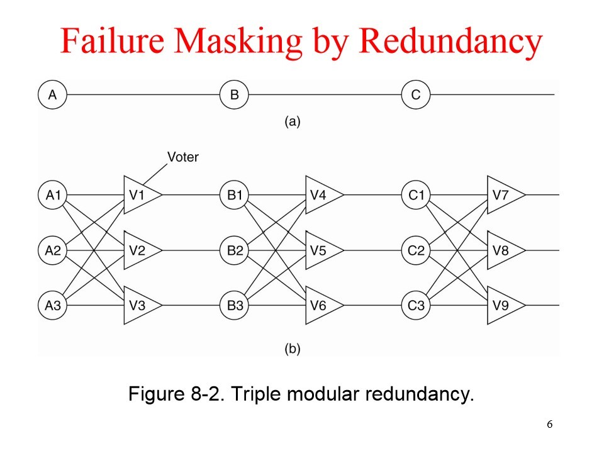
- What will happen if only A1 fails?
  - If A1 fails, it cannot vote. As such, if A2 and A3 are fine and agree, the vote V1 will transmit, allowing for B1 to continue.
- What will happen if only V2 fails?
  - If V2 fails, the second device will not be able to continue. This, however, does not prevent the first and third devices from continuing.
- What will happen if both B2 and B3 fail?
  - If both B2 and B3 fail, then all devices will halt at B. This is because there will not be agreement of 2 or more devices, so all devices will have varying votes, which will prevent continuation to C.
(80 points) 2. Please read the posted paper “MapReduce: Simplified Data Processing on Large Clusters” by Jeffrey Dean and Sanjay Ghemawat, OSDI ’04: 6th Symposium on Operating Systems Design and Implementation, 2004.
You may ignore the complex analysis and focus on what we have discussed in the class. After reading please write a brief survey (about 400 words) to summarize MapReduce and its major functions from a distributed system perspective.

A paper from Google, this insightful work demystifies the essence of MapReduce as a tool utilized in parsing large quantities of data in various forms across many systems in a rather short time frame. Focusing on simplicity in abstraction, the authors seek to provide an understanding of the basic interface, usage, and experience of usage in Google.
The authors begin with a programming model, laying down the basics of the functions Map and Reduce. The Map function has an input and produces an “intermediate key/value pair”. This intermediate pair is then picked up by the Reduce function, which takes and combines all the values with the same key, producing a smaller set of values. “Typically just zero or one output value is produced per Reduce invocation.” All the intermediate keys are iterated through for the Reduce function. A few examples are given, such as occurrences of words in documents, Grep, URL frequency, and more, alongside an emphasis on the domains the keys and values are drawn from (throughout the process).
The following two sections (3 & 4) focused on the implementation and refinements. Requiring multiple higher-end computers and enough storage will allow for the implementation. The Map function firsts split the data and assigns them to machines in the form of tasks, which are processed in parallel. These are individual programs that run on each computer, with a specific program denoted as the master, which is given the responsibility to assign the tasks. When finished with all the Map function, the result is written to the local disk (of the machine that did the process). The Reduce task is then handed out and processed. Using RPC calls, the machines are able to access the intermediate keys and output the result to a final output file. Finally, the master wakes the user program, returning the cumulative final result. As this is a lower-level process that is hidden from the user, failure must also be hidden. If a worker fails doing Map, it defaults to the idle state and is assigned a task (most likely to rerun the same task, though completed workers will also default, allowing it to be used again). Any Reduce workers that incomplete execution will have to be re-run, but if they are complete, there is no need for re-running as the file is already stored in a reliable location (the global file system). The master creates checkpoint in case of failure, which allows easy recovery. The global file system, or GFS, has several copies on different machines, also allowing for redundancy. Partitioning of the data, ordering, and combining are all implemented per program, allowing for unity on all accounts.
The last sections of the paper close with additional information. With focuses on backups, machine failures, and other general performance measures, these details summarize the effectiveness and usefulness of such a system. Alongside this, the related works and its application at Google prove its efficacy and reliability. “We attribute this success to several reasons. First, the model is easy to use, even for programmers without experience with parallel and distributed systems, since it hides the details of parallelization, fault-tolerance, locality optimization, and load balancing. Second, a large variety of problems are easily expressible as MapReduce computations.”

How to Turn In:
Softcopy: Please use BlackBoard to turn in your homework solutions.

